
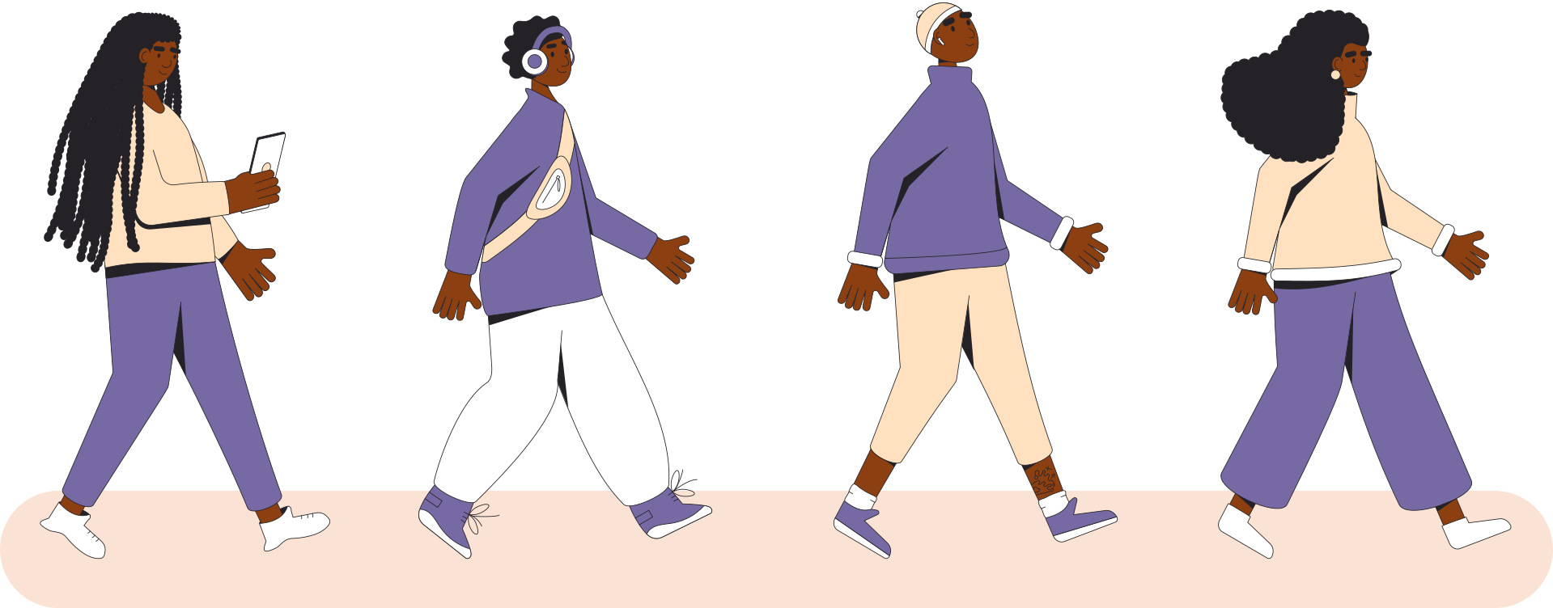
CHORE CHART
FOR TEENS
Chore 1
Chore 3
Chore 4
Chore 5
Chore 2
M
T
W
T
F
S
S

